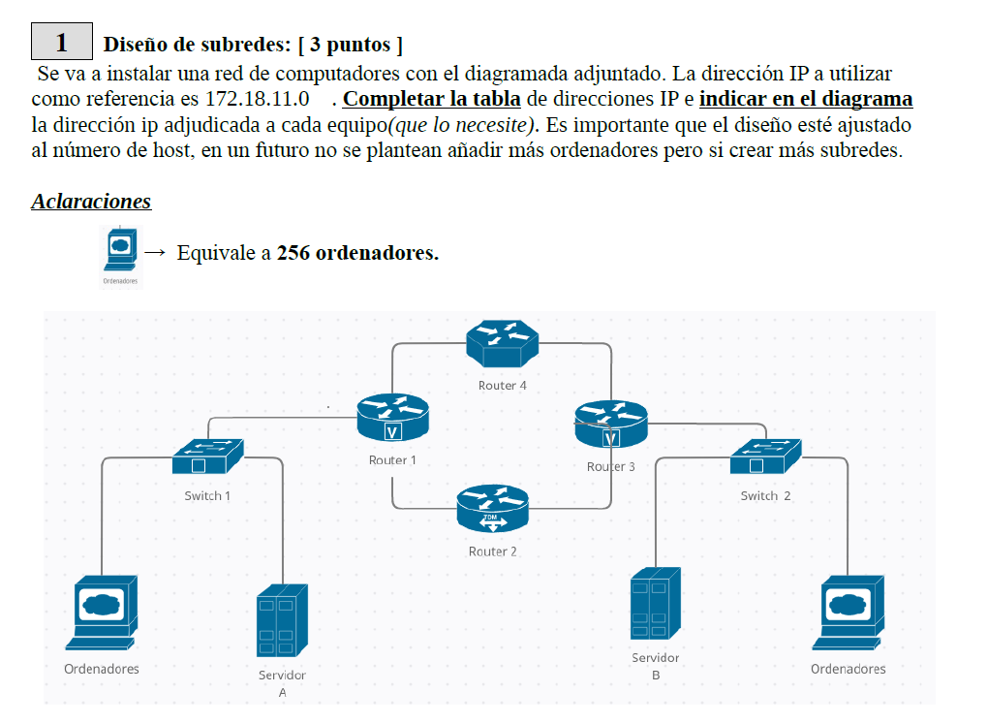
RED 1
RED 2
RED 3
RED 4
RED 5
RED 6

